**ĐẠI HỌC QUỐC GIA THÀNH PHỐ HỒ CHÍ MINH**

**TRƯỜNG ĐẠI HỌC KHOA HỌC TỰ NHIÊN**

**KHOA CÔNG NGHỆ THÔNG TIN**

**🙢🙢🙢🙢🙢🙢🙢🙢🙢🙢**



**KHAI THÁC DỮ LIỆU VÀ ỨNG DỤNG**

**CSC1404_21KHMT1**

**LAB 1**

**DATA PREPROCESS**

**21127592 – Nguyễn Minh Đạt**

**21127191 – Nguyễn Nhật Truyền**

**Contents**

**1. Group Information** 1

**2. Install WEKA** 1

**3. Getting Acquainted With WEKA** 4

**3.1 Exploring Breast Cancer data set** 4

**3.2 Exploring Weather data set** 9

**3.3 Exploring Credit in Germany data set** 11

**4. Code Demo** 17

**4.1 Extract columns with missing values:** 17

**4.2 Count the number of lines with missing data:** 18

**4.3 Fill in the missing value using mean, median (for numeric properties) and mode (for the categorical attribute:** 18

**4.4 Deleting rows containing more than a particular number of missing values (Example: delete rows with the number of missing values is more than 50% of the number of attributes):** 19

**4.5 Deleting columns containing more than a particular number of missing values (Example: delete columns with the number of missing values is more than 50% of the number of samples):** 20

**4.6 Delete duplicate samples:** 21

**4.7 Normalize a numeric attribute using min-max and Z-score methods:** 22

**4.8 Performing addition, subtraction, multiplication, and division between two numerical attributes:** 23

# 

# **1. Group Information**

|  |  |  |  |
| --- | --- | --- | --- |
| Student’s ID | Name | Task | Contribution |
| 21127592 | Nguyễn Minh Đạt | * Install WEKA * Getting Acquainted With WEKA | 50% |
| 21127191 | Nguyễn Nhật Truyền | * Processing Data With Python | 50% |

Uncompleted requirements:

* Breast Cancer data set:
  + Let’s explain the meaning of the chart in the WEKA Explorer. Setting the title for it and describing its legend.
* Weather data set:
  + Let’s explain the meaning of the chart in the WEKA Explorer. Setting the title for it and describing its legend.
  + Do you think there are any pairs of different attributes that have correlated?
* Credit in Germany data set:
  + Let’s explain the meaning of the chart in the WEKA Explorer. Setting the title for it and describing its legend.

# **2. Install WEKA**

– **Requirement 1:** After installing, you capture a screen that contains the ”Explorer” function in your desktop background.

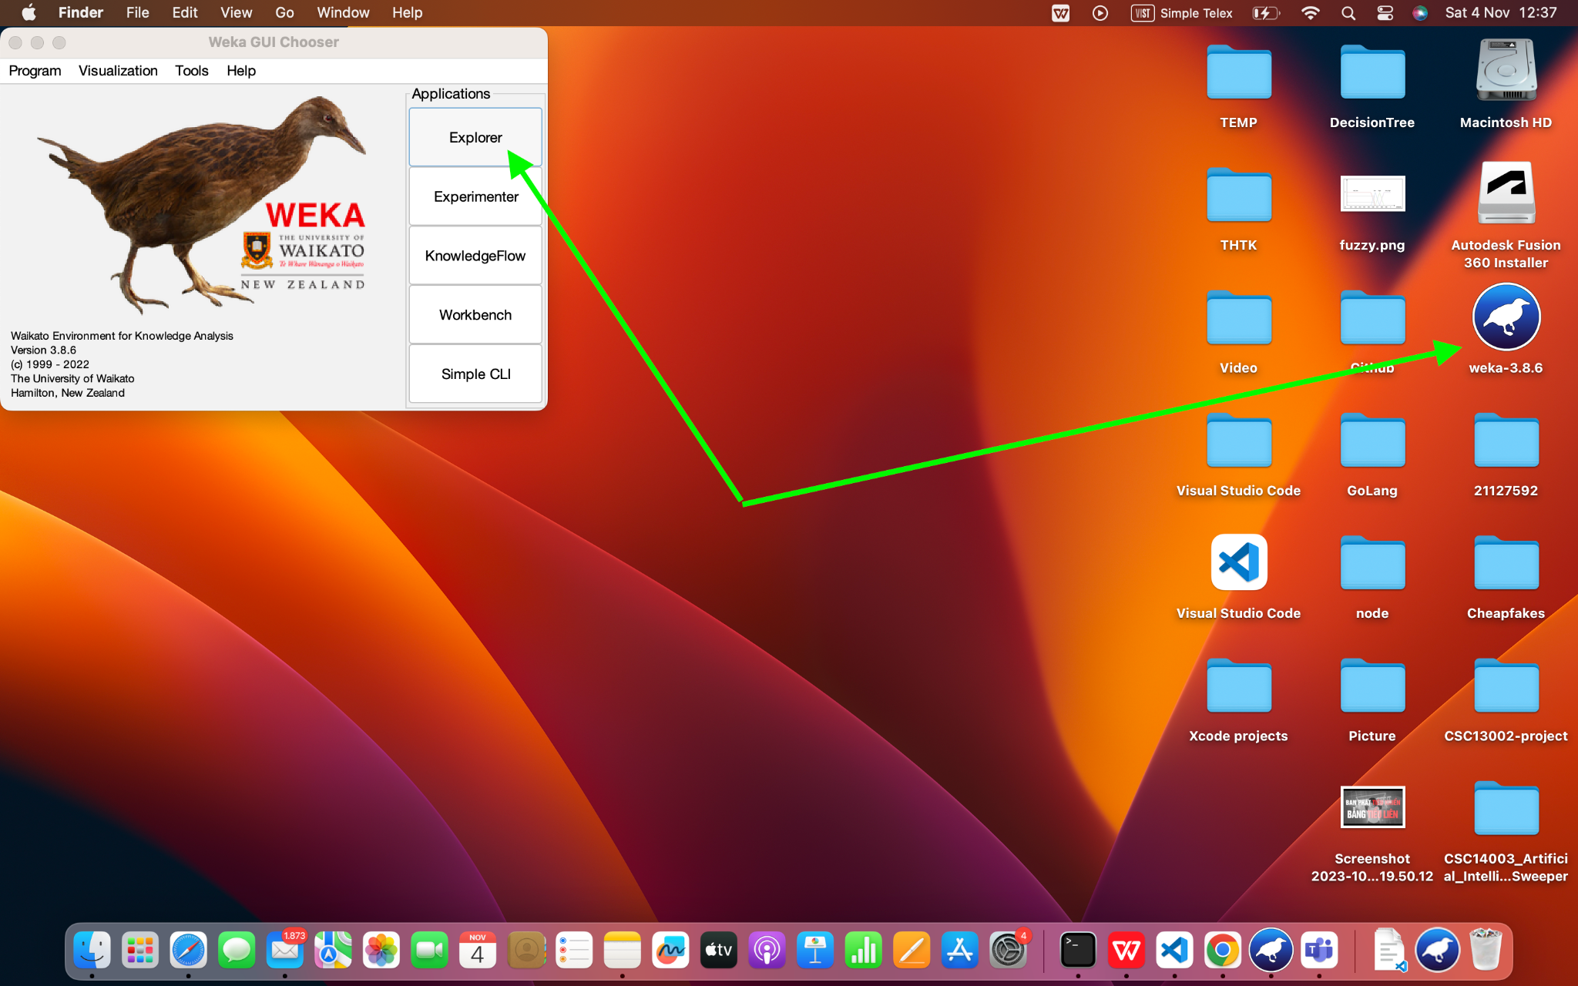

– **Requirement 2:** Students open any data set (with extended part .arff). Explain the meaning of **Current Relation**, **Attributes**, and **Selected Attribute** in the **Preprocess** tag. Briefly explain the meaning of the other tags in WEKA Explorer.

Selected dataset file: **iris.arff**

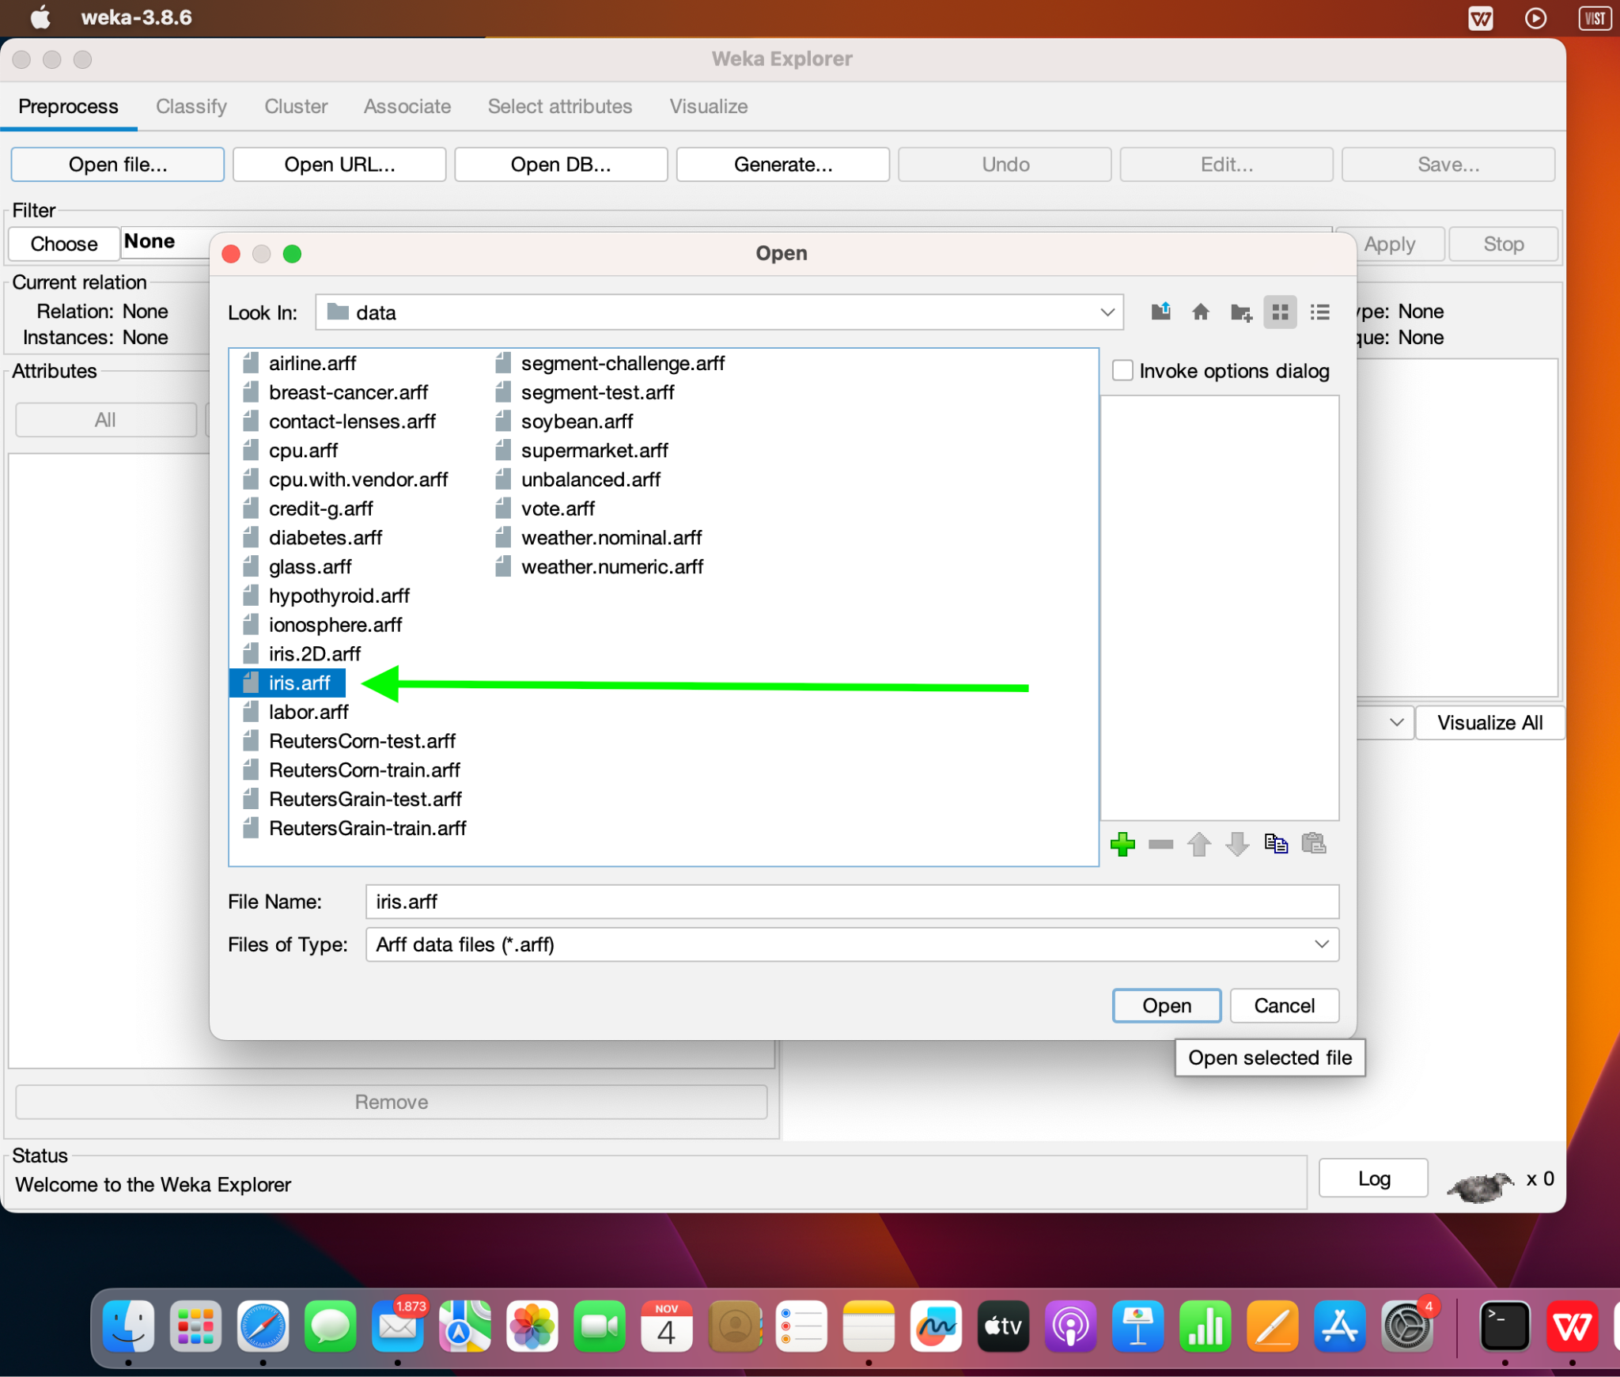

Tags explanation:

1. **Current Relation**:

* This tag provides information about the current dataset, such as its name, the number of attributes, the number of instances, and the sum of weights.

2. **Attributes**:

* The Attributes tag presents a list of all the attributes in the dataset.
* This section helps examine and manipulate the attributes of the dataset, such as removing attributes from the dataset.

3. **Selected Attribute**:

* The Selected Attribute tag displays the details of the attribute that is currently selected.
* It provides information about the selected attribute, such as its name, data type, the number of missing values, and other properties.
* This section helps analyze and modify the properties of a specific attribute.

Apart from the Preprocess tab, WEKA Explorer has other tags that serve different purposes.

- **Classify**: The Classify tag is used for building and evaluating classification models on the dataset. It provides various algorithms and options for training and testing classifiers.

- **Cluster**: The Cluster tag is used for clustering analysis on the dataset. It offers different clustering algorithms and settings to group similar instances together.

- **Associate**: The Associate tag is used for association rule mining on the dataset. It helps discover interesting relationships or patterns among different attributes or items.

- **Visualize**: The Visualize tag provides visualization options to visualize the dataset or the results of different analysis tasks. It offers various plots, charts, and graphs to aid in understanding the data and analysis outcomes.

- **Select attributes**: The Select attributes tag is used for feature selection or attribute subset selection. It offers different methods to select the most relevant or informative attributes from the dataset.

# **3. Getting Acquainted With WEKA**

## **3.1 Exploring Breast Cancer data set**

– How many instances does this data set have? **Answer**: 286

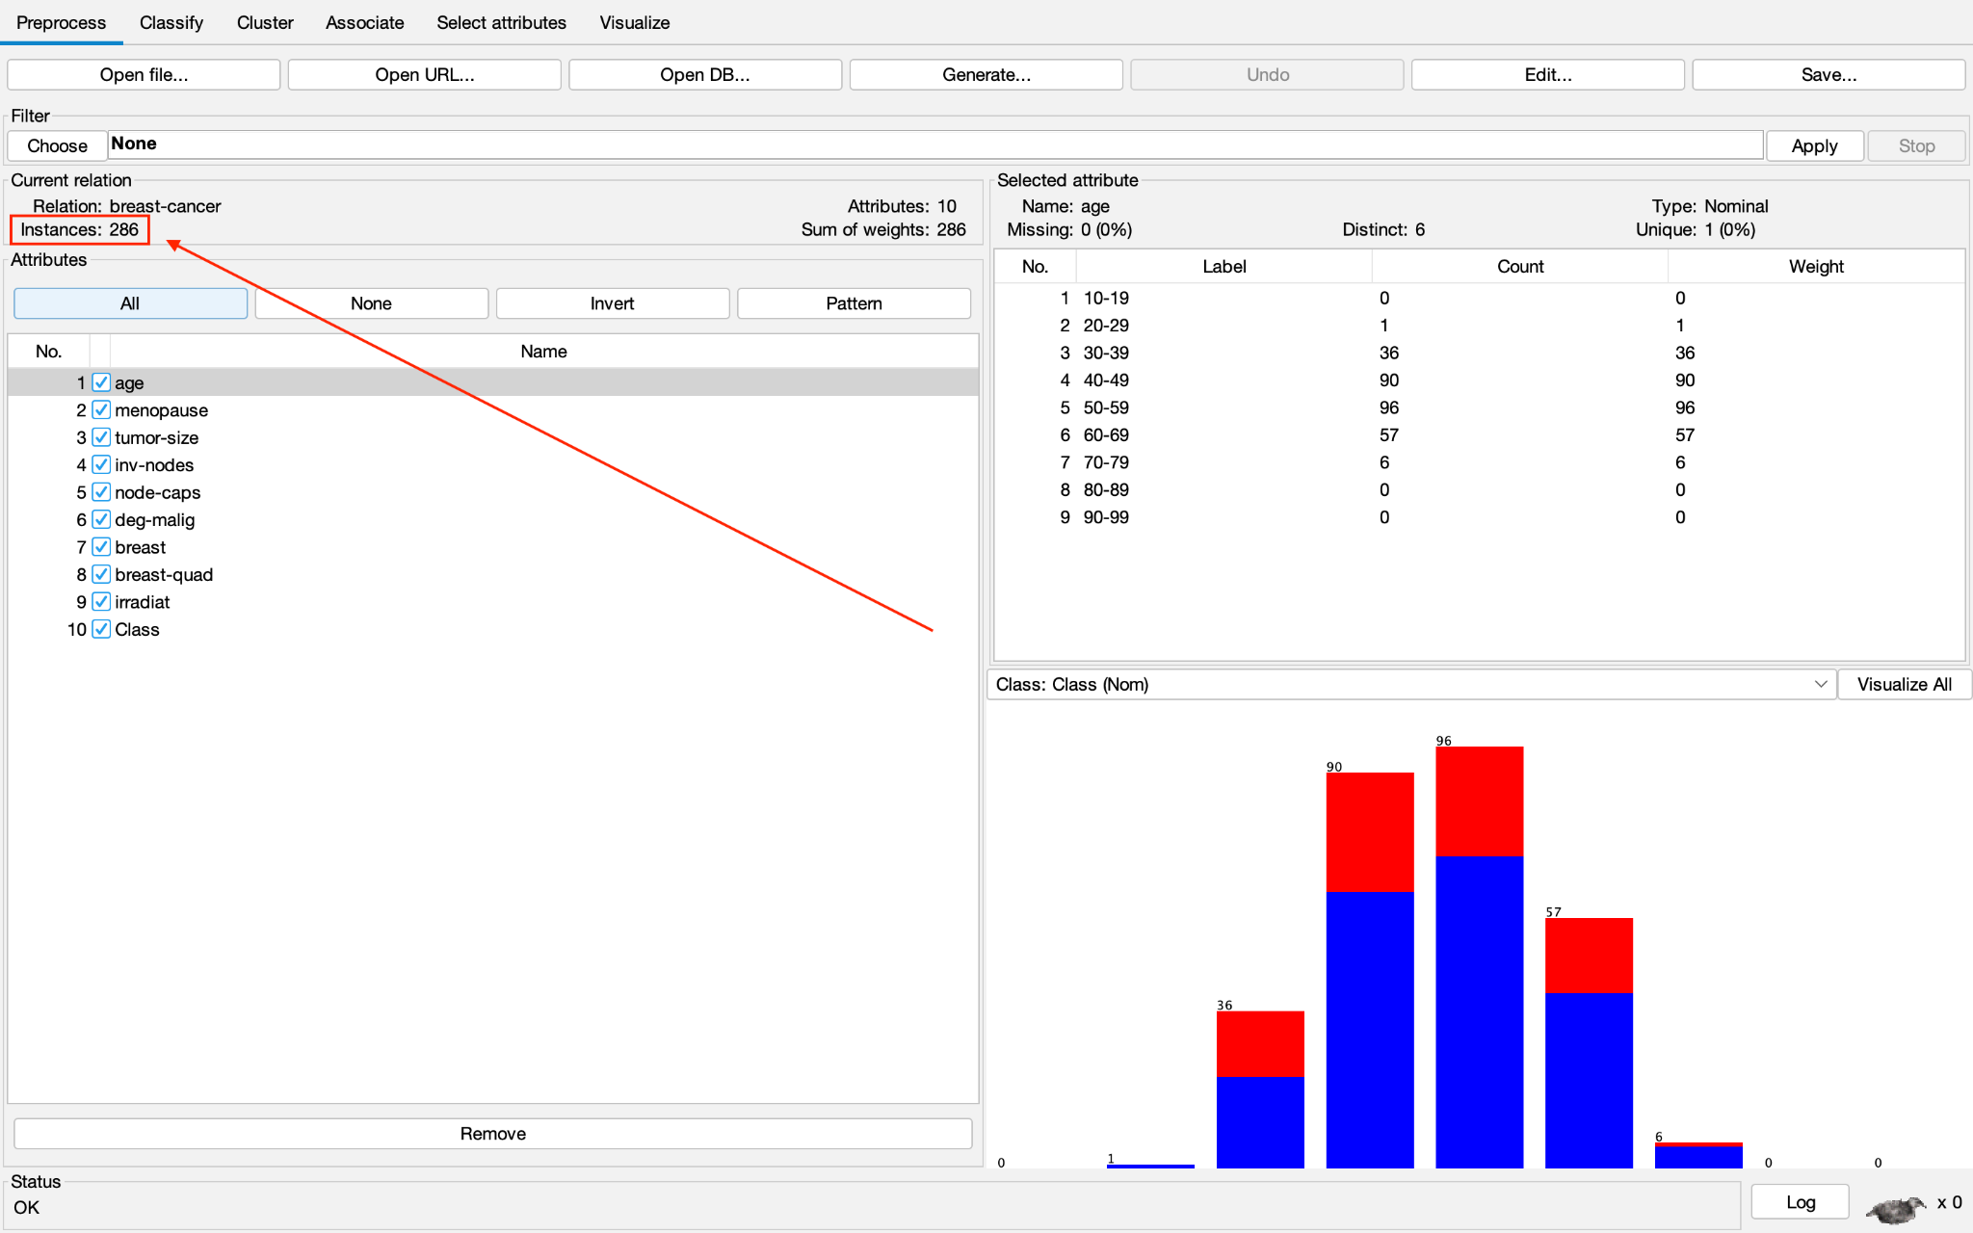

– How many attributes does this data set have? **Answer**: 10

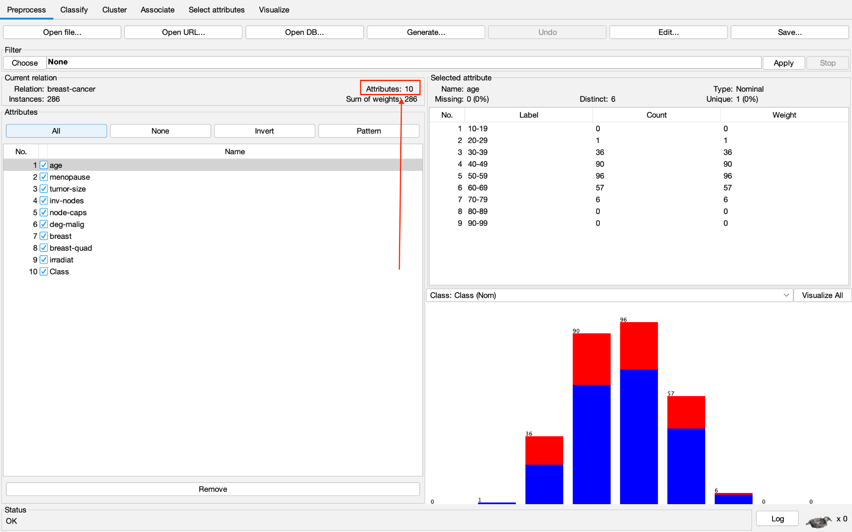

– Which attribute is used for the label? Can it be changed? How?

**Answer**:

* The attribute used for the label is “**Class**”.

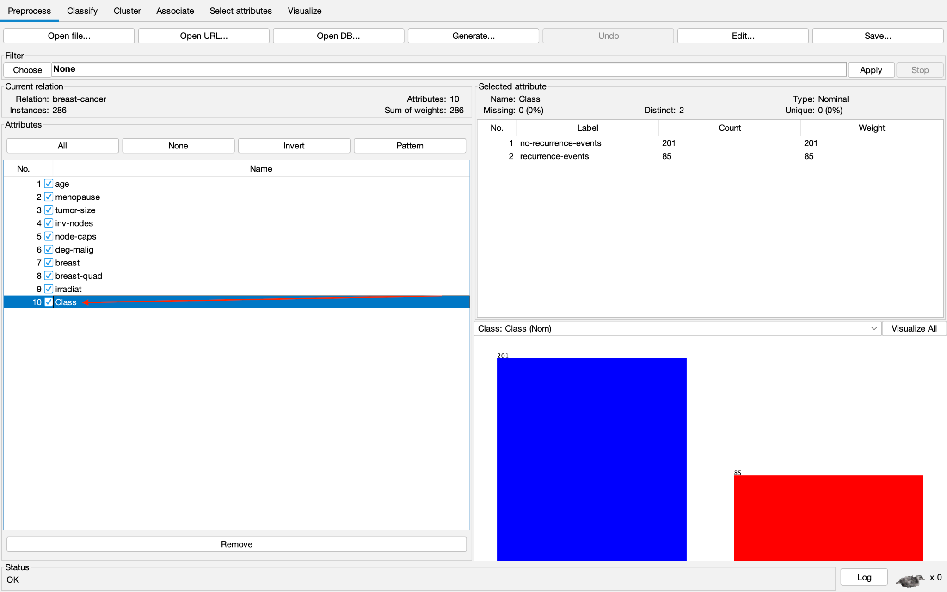

* The attribute used for the label can be changed by:
  + Clicking the down arrow from the box

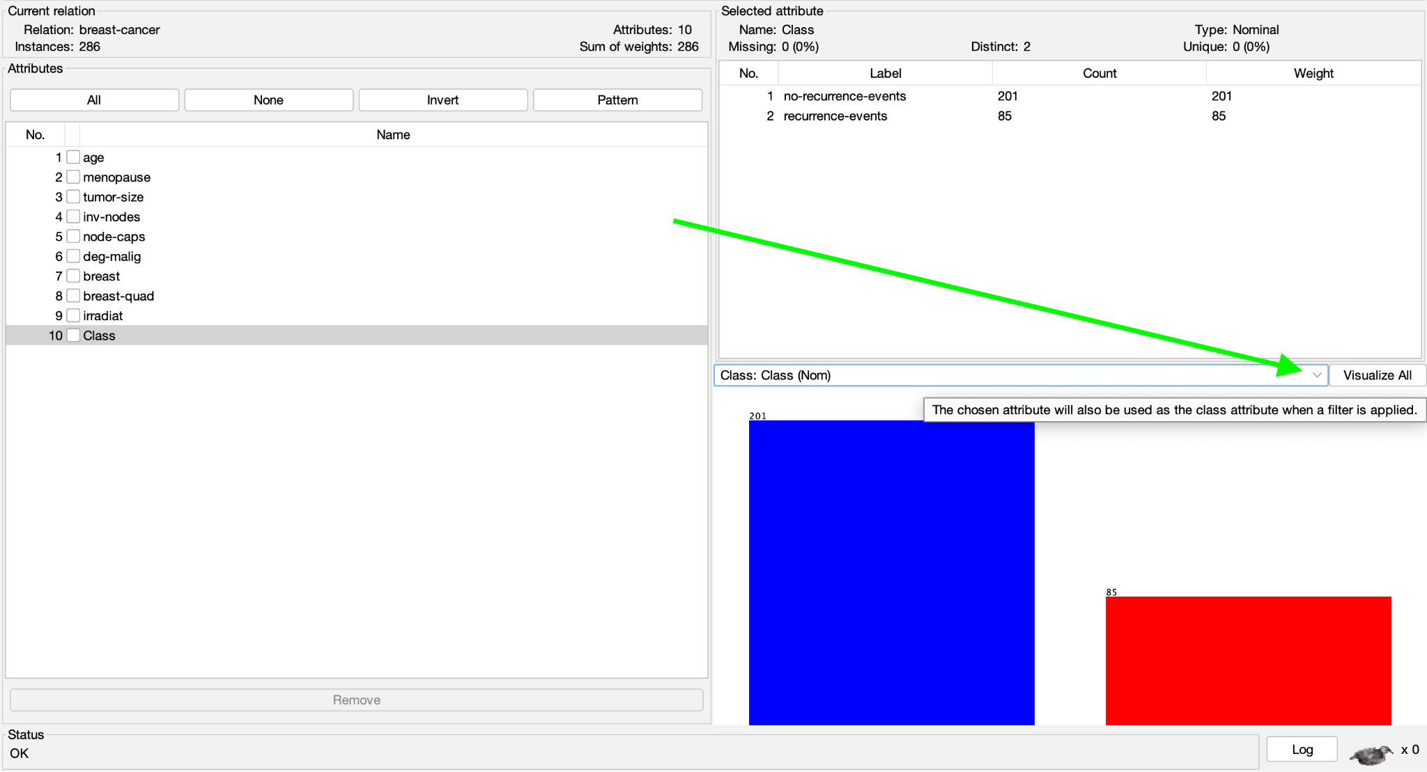

* + Choose an alternative attribute to be used as the class attribute

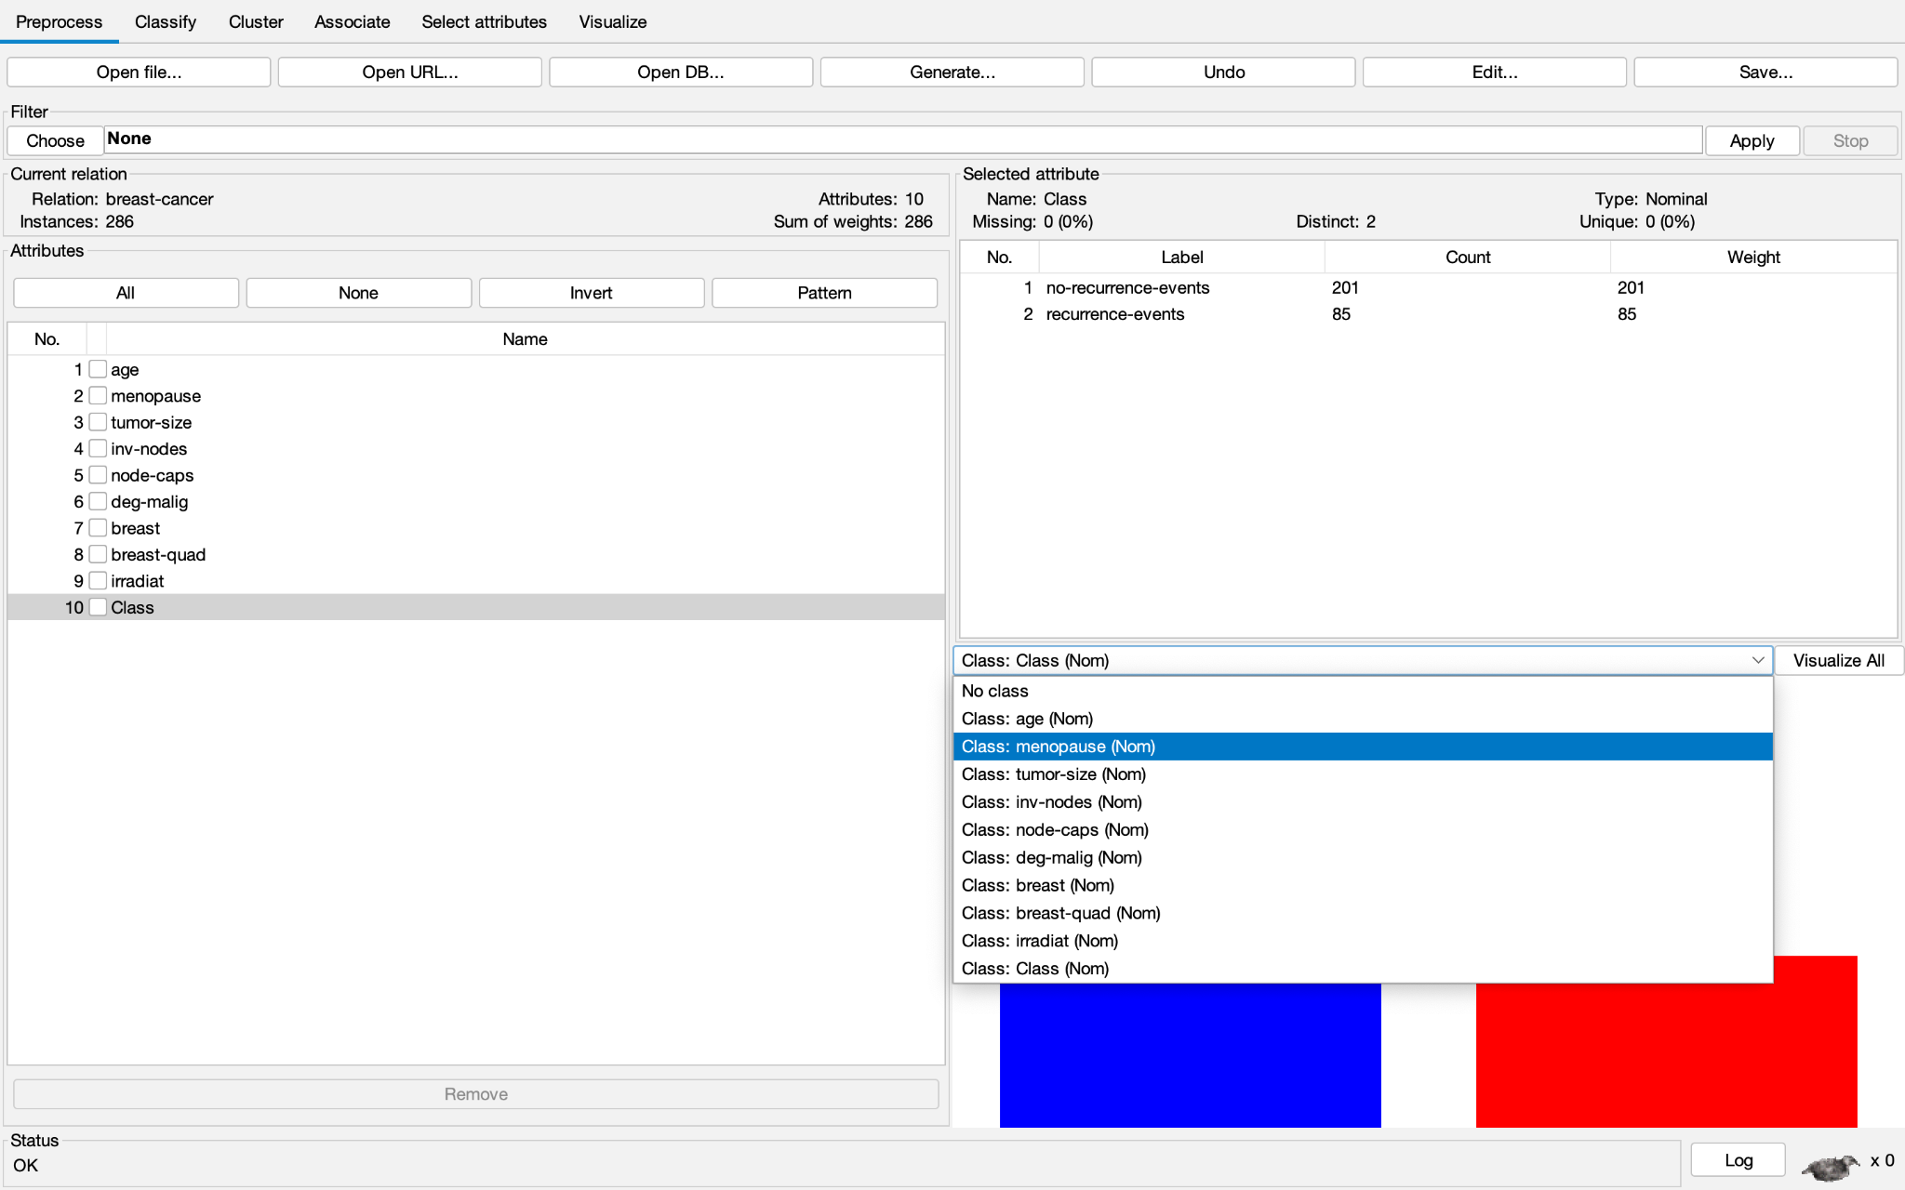

– What is the meaning of each attribute?

|  |  |  |  |
| --- | --- | --- | --- |
|  | **Name** | **Type** | **Meaning** |
| 1 | age | Nominal | The attribute "age" refers to the age of individuals within the dataset. |
| 2 | menopause | Nominal | The attribute "menopause" refers to the menopausal status of individuals within the dataset. |
| 3 | tumor-size | Nominal | The attribute "tumor-size" refers to the size or dimensions of the tumor associated with breast cancer. |
| 4 | inv-nodes | Nominal | The attribute "inv-node" refers to the involvement of lymph nodes in breast cancer. |
| 5 | node-caps | Nominal | The attribute "node-caps" refers to the presence or condition of the capsule surrounding the lymph nodes in breast cancer cases. |
| 6 | deg-malig | Nominal | The attribute "deg-malig" refers to the degree of malignancy or the level of tumor aggressiveness in breast cancer cases. |
| 7 | breast | Nominal | The attribute "breast" refers to the location or side of the breast affected by breast cancer. |
| 8 | breast-quad | Nominal | The attribute "breast-quad" refers to the quadrant or region of the breast where the tumor or abnormality associated with breast cancer is located. |
| 9 | irradiat | Nominal | The attribute "irradiat" refers to whether or not the patient received radiation therapy as part of their breast cancer treatment. |
| 10 | Class | Nominal | The attribute "Class" refers to the classification or categorization of breast cancer cases based on their characteristics or outcomes. |

– Let’s investigate the missing value status in each attribute and describe in general ways to solve the problem of missing values.

* Attributes with missing values:
  + node-caps (**8** missing values)
  + breast-quad (**1** missing value)
* Handling the problem of missing values:
  + Removal: If the missing values are concentrated in a small portion of the dataset and the missingness is random, we can consider removing the instances or attributes with missing values. However, this approach may result in a loss of valuable data.
  + Mean/Median/Mode imputation: For numerical attributes, we can replace missing values with the mean, median, or mode of the non-missing values in that attribute. This approach assumes that the missing values are similar to the existing values.
  + Regression imputation: If the missing values have a correlation with other attributes, you can use regression models to predict the missing values based on the other attributes. This approach requires building a regression model using non-missing values as the training data.

– Let’s propose solutions to the problem of missing values in the specific attribute.

* Attribute: node-caps (**8** missing values)
  + Because the missing values in the "node-caps" attribute account for only **3**% of the total instances, considering the removal of those instances or replacing the missing values with the **mode** of the attribute would be a reasonable approach.

– Let’s explain the meaning of the chart in the WEKA Explorer. Setting the title for it and describing its legend. (uncompleted)

## **3.2 Exploring Weather data set**

– How many attributes does this data set have? **Answer**: 5.

– How many samples? **Answer**: 14

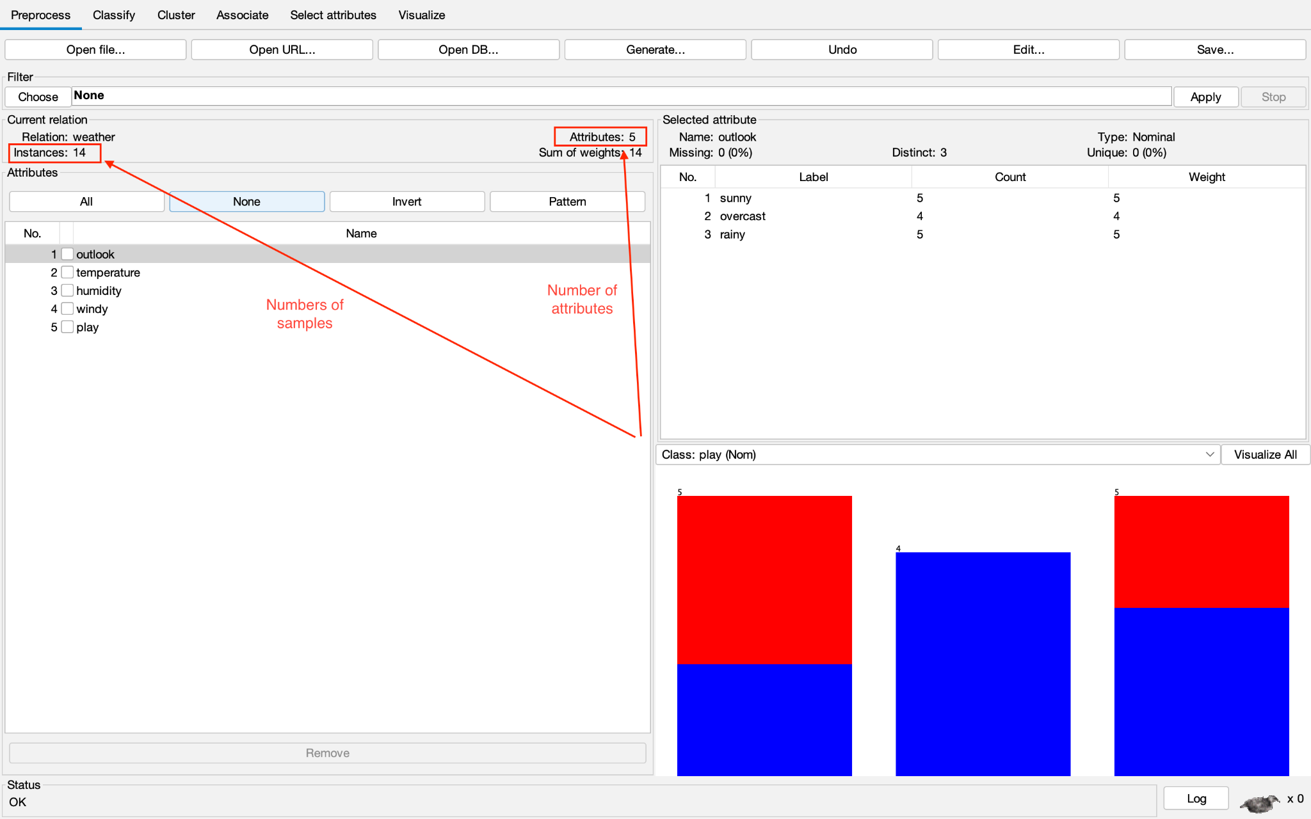

– Which attributes have data type categorical?

**Answer**: 3 (outlook, windy, play)

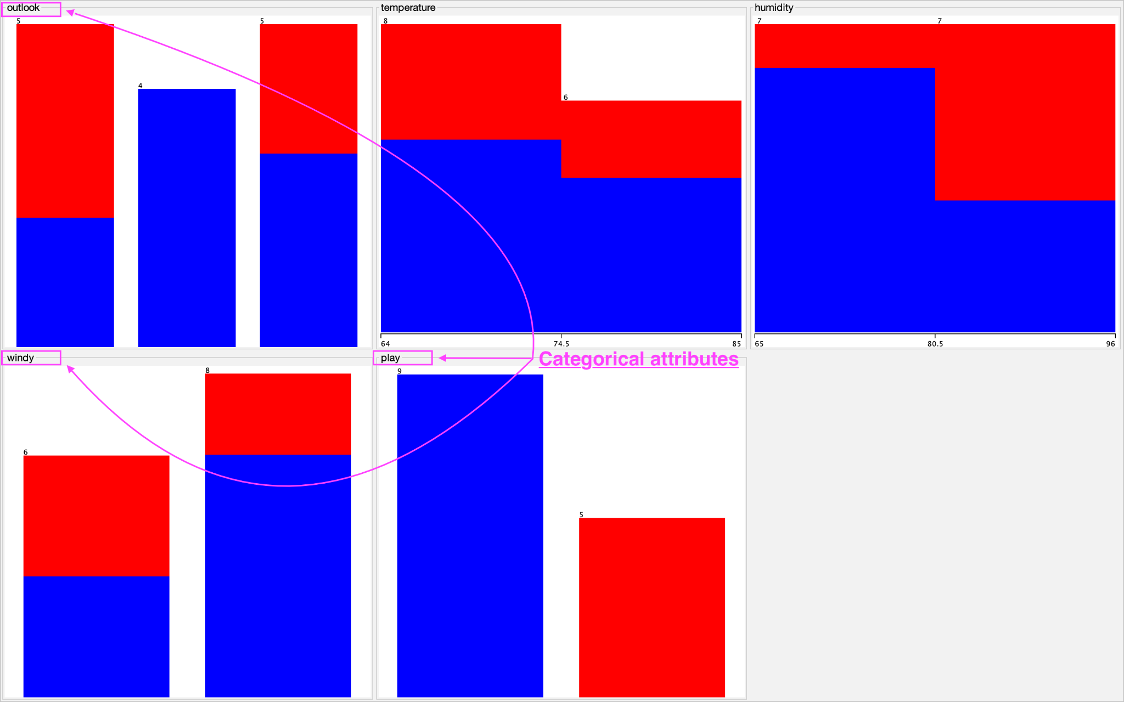

– Which attributes have a data type that is numerical?

**Answer**: 2 (temperature, humidity)

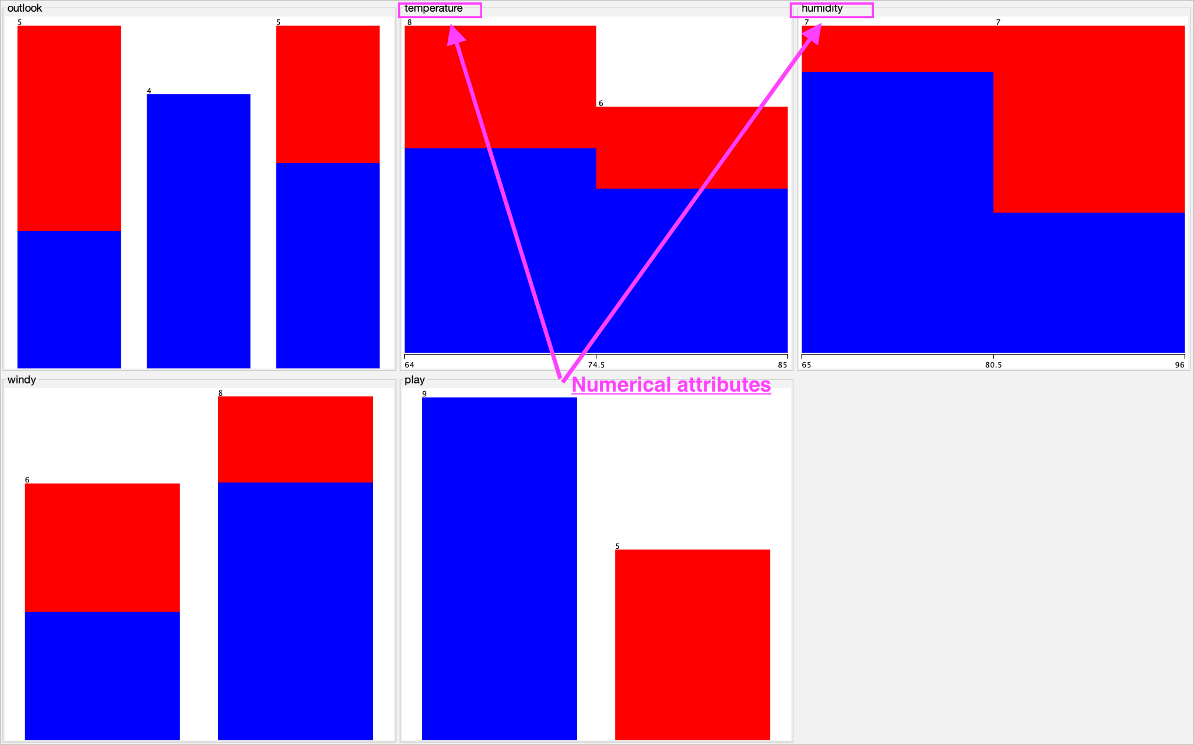

– Which attribute is used for the label? **Answer**: play

– Let’s list a five-number ***summary*** of two attributes: temperatureand **humidity**. Does WEKA provide these values?

|  |  |  |
| --- | --- | --- |
| Temperature | Minimum | 64 |
| Maximum | 85 |
| Mean | 73.571 |
| StdDev | 6.572 |
| Humidity | Minimum | 65 |
| Maximum | 96 |
| Mean | 81.643 |
| StdDev | 10.285 |

– Let’s explain the meaning of all charts in the WEKA Explorer. Setting the title for it and describing its legend. (uncompleted)

– Let’s move to the **Visualize** tag.

* What’s the name of this chart?
  + **Answer**: Plot Matrix (a matrix of scatter plots where each plot displays the relationship between two variables from a dataset)
* Do you think there are any pairs of different attributes that have correlated? (uncompleted)

## **3.3 Exploring Credit in Germany data set**

– What is the content of the comments section in **credit-g.arff** (when opened with any text editor) about?

**Answer**: The content of the comments section in **credit-g.arff** is about:

* Description of the German credit dataset.
  + Title
  + Source Information
  + Number of Instances
  + Number of Attributes
  + Attribute description
  + Cost Matrix
  + Relabeled values in attributes

– How many samples does the data set have? **Answer**: 1000.

– How many attributes? **Answer**: 21.

– Describe any five attributes (must have both discrete and continuous attributes).

|  |  |  |  |
| --- | --- | --- | --- |
|  | **Name** | **Type** | **Meaning** |
| 1 | credit_history | Nominal | The attribute "credit_history" refers to the past credit history or repayment behavior of an individual. |
| 2 | credit_amount | Numeric | The attribute "credit_amount" refers to the amount of credit requested or granted to an individual. |
| 3 | employment | Nominal | The attribute "employment" refers to the employment status of an individual. |
| 4 | age | Numeric | The attribute "age" refers to the age of an individual. |
| 5 | housing | Nominal | The attribute "housing" refers to the type of housing or accommodation that an individual resides in. |

– Which attribute is used for the label? **Answer**: attribute “class”

– Let’s describe the distribution of continuous attributes? (Left skewed or right skewed ?)

|  |  |
| --- | --- |
| **Attribute (of type continuous)** | **Description** |
| duration | Right-skewed |
| credit_amount | Right-skewed |
| installment_commitment | Left-skewed |
| residence_since | Left-skewed |
| age | Right-skewed |
| existing_credits | Right-skewed |
| num_dependents | Right-skewed |

– Let’s explain the meaning of all charts in the WEKA Explorer. Setting the title for it and describing its legend. (uncompleted)

– Let’s move to the Select attributes tag. Describe all of the options for attribute selection.

**Answer:**

* **CfsSubsetEval**: This option evaluates subsets of attributes by considering their individual predictive ability and their redundancy with other attributes. It uses correlation measures to determine the quality of attribute subsets.
* **ClassifierAttributeEval**: This option evaluates attributes by training a classifier on each attribute individually and measuring their individual predictive accuracy. It provides an estimate of the predictive power of each attribute independently.
* **ClassifierSubsetEval**: This option trains a classifier on subsets of attributes and evaluates their predictive accuracy. It considers the interaction and combined predictive power of attribute subsets, allowing for more accurate attribute selection than evaluating attributes individually.
* **CorrelationAttributeEval**: This option evaluates attributes based on their correlation with the class variable. It measures the linear relationship between each attribute and the class and selects attributes with high correlation.
* **GainRatioAttributeEval**: This option calculates the gain ratio of each attribute. It measures the information gain of an attribute taking into account the intrinsic information of the attribute and normalizes it to handle attributes with a large number of distinct values.
* **InfoGainAttributeEval**: This option calculates the information gain of each attribute. It measures the reduction in entropy or uncertainty provided by each attribute and selects attributes with the highest information gain.
* **OneRAttributeEval**: This option applies the OneR algorithm to assess the predictive accuracy of each attribute. It determines the attribute with the best performance when used as the single decision rule for classification.
* **PrincipalComponents**: This option performs principal component analysis (PCA) on the attributes. It transforms the original attributes into a new set of uncorrelated attributes called principal components. You can specify the number of components to retain.
* **ReliefFAttributeEval**: This option employs the ReliefF algorithm to estimate the quality of attributes based on their ability to distinguish between instances of different classes. It considers the nearest neighbors of each instance and updates the weights of attributes accordingly.
* **SymmetricalUncertAttributeEval**: This option estimates the symmetrical uncertainty of each attribute. It measures the amount of shared information between the attribute and the class and selects attributes that have a high degree of relevance and low redundancy.
* **WrapperSubsetEval**: This option uses a machine learning algorithm as a wrapper to evaluate subsets of attributes. It trains and tests the classifier on different attribute subsets and selects the subset that results in the best classifier performance.

– Which options should be used to select the 5 attributes with the highest correlation? (Step-by-step description, with step-by-step photos and final results)

**Answer**:

* Once the dataset is loaded, go to the "**Select attributes**" tab in WEKA Explorer.

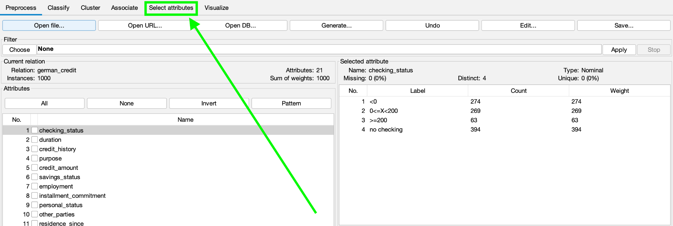

* Click on the "Choose" button next to the "**Attribute Evaluator**" field. This will open the "Choose" window.

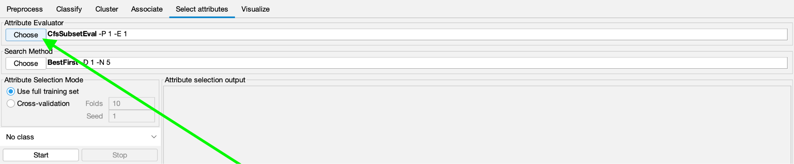

* In the "Choose" window, select the "**CorrelationAttributeEval**" option from the list of attribute evaluators. This evaluator calculates the correlation between attributes and the class label.

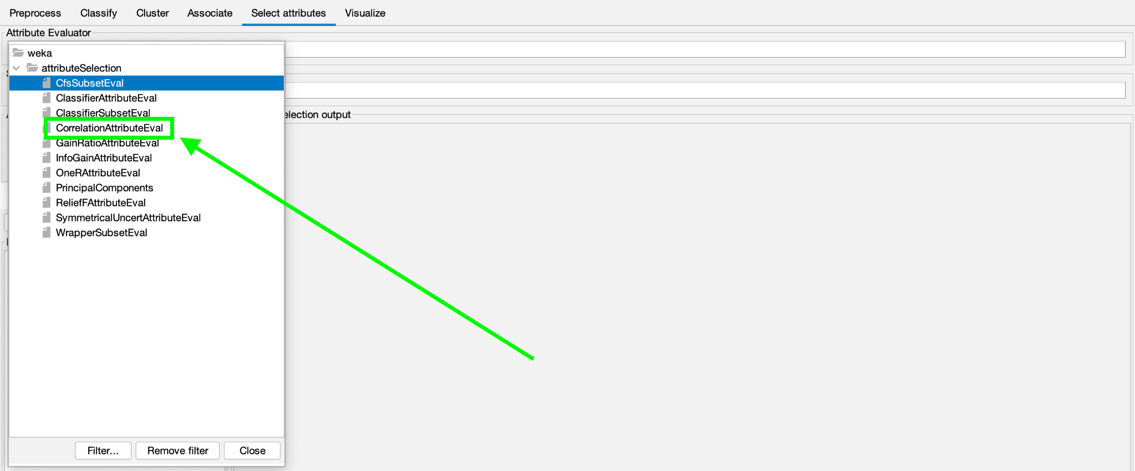

* In the "**Select attributes**" panel, select the "**Search Method**" dropdown menu and choose an appropriate search method for finding the attribute subset with high correlation. For example, you can select "**Ranker**" as the search method.

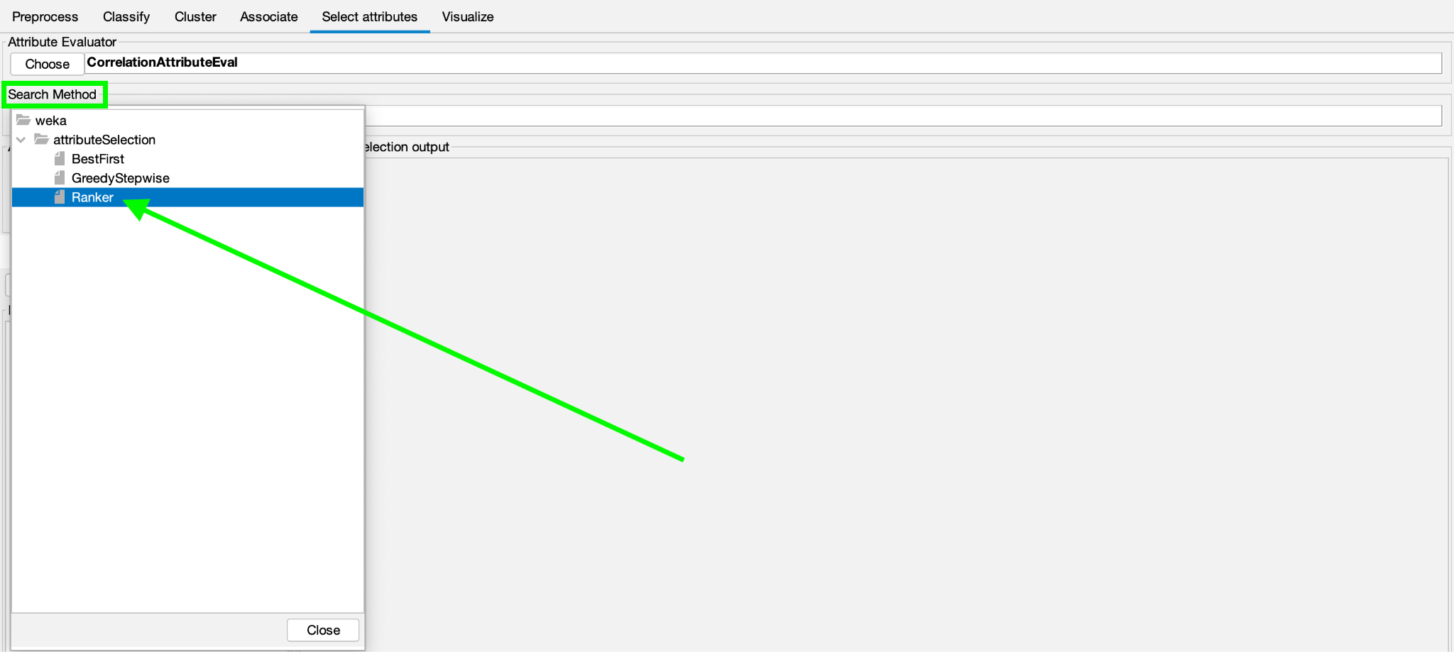

* Specify the number of attributes you want to select. In this case, set the value to 5.

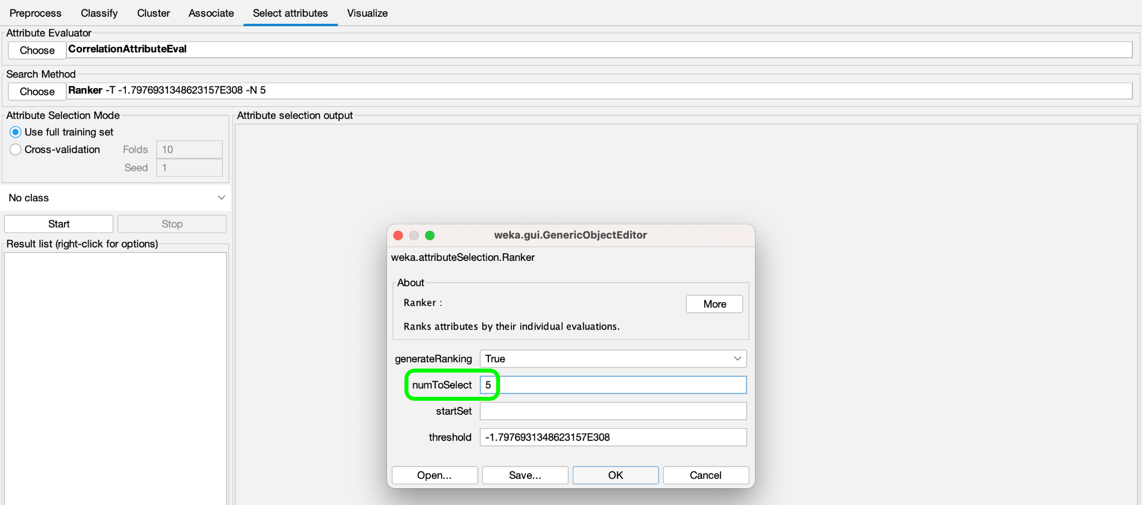

* Click the "**Start**" button to begin the attribute selection process.

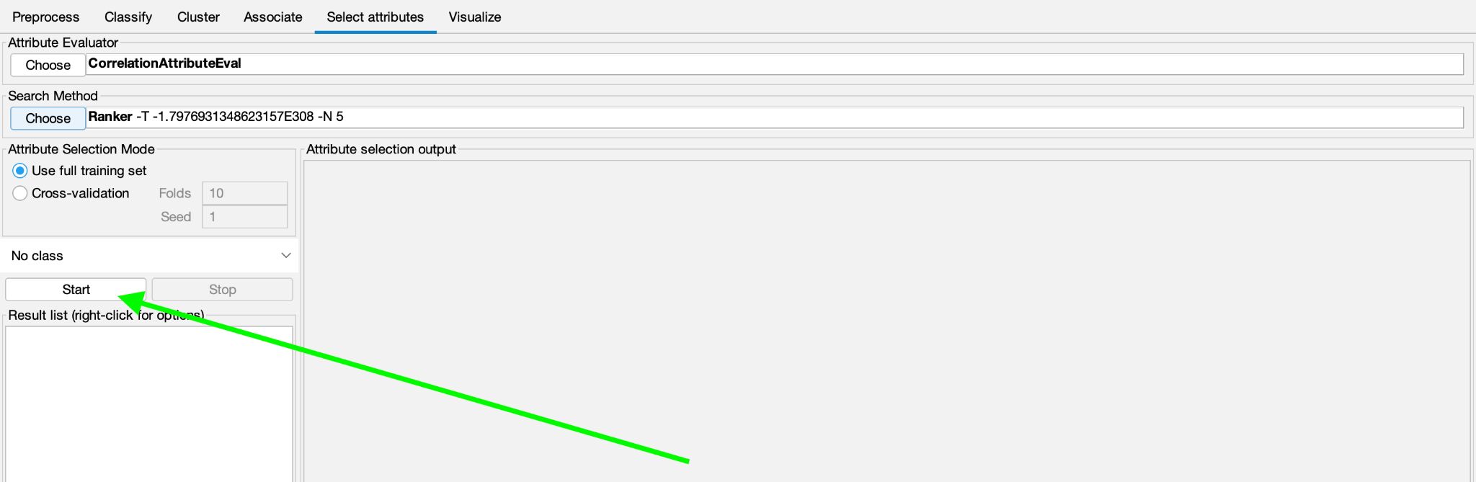

* **Final result**:

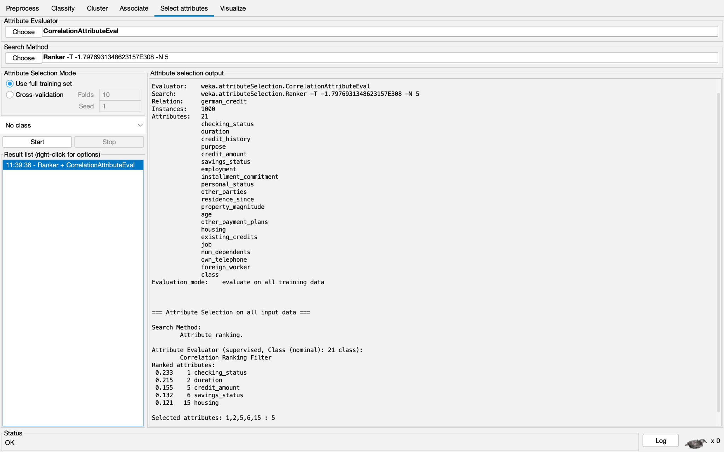

# **4. Code Demo**

Locate the folder where all the code files and data file are located

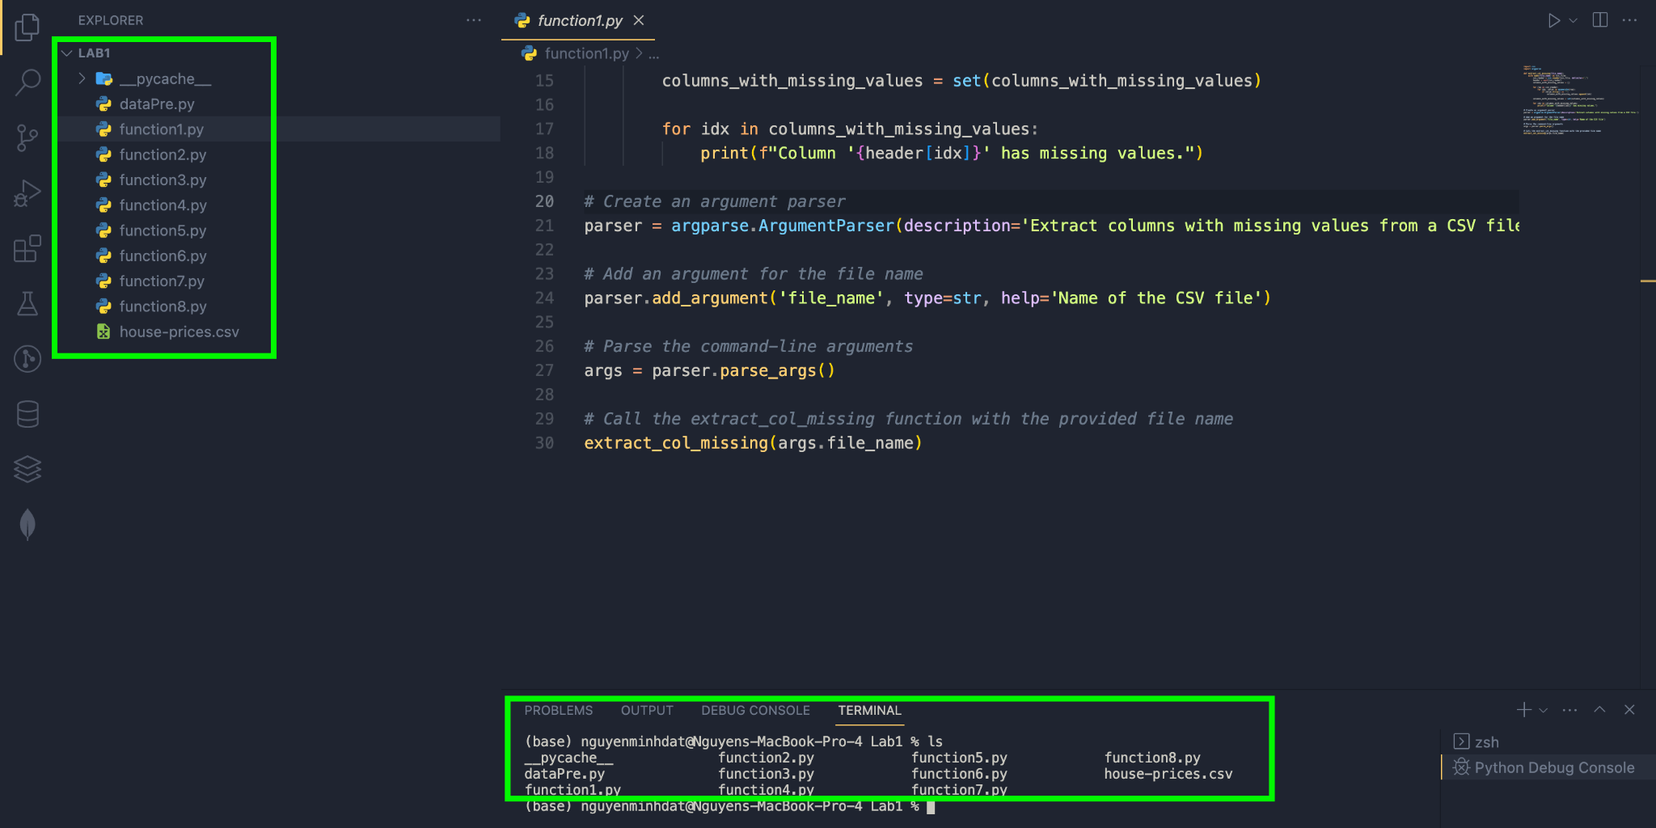

## **4.1 Extract columns with missing values:**

Command line:

|  |
| --- |
| python function1.py house-prices.csv |

After selecting this function, the names of the columns with missing values will be displayed on the terminal.

With house-prices.csv data set, we have the results.

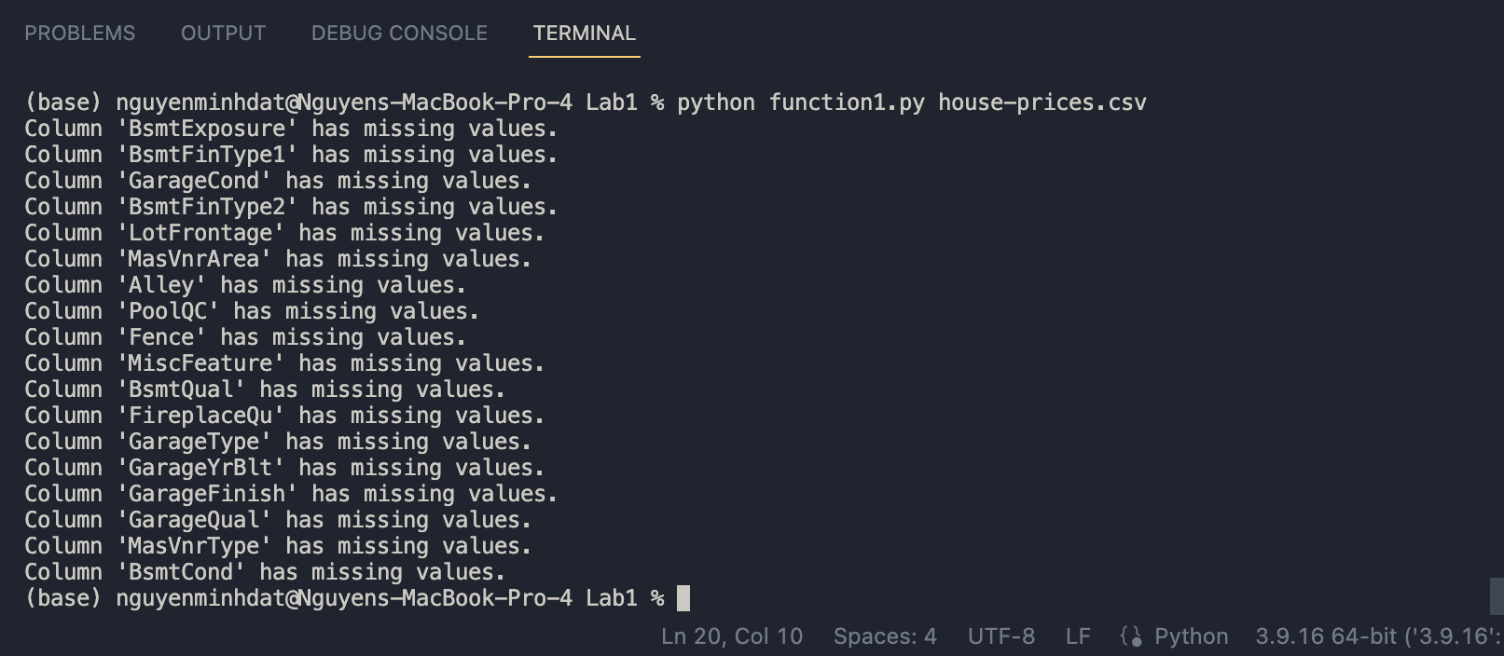

## **4.2 Count the number of lines with missing data:**

Command line:

|  |
| --- |
| python function2.py house-prices.csv |

After selecting this function, the result values will be displayed on the terminal.

With house-prices.csv data set, we have the results.

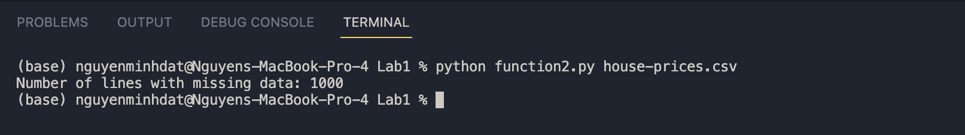

## **4.3 Fill in the missing value using mean, median (for numeric properties) and mode (for the categorical attribute:**

Command line:

|  |
| --- |
| python function3.py house-prices.csv --method mean --columns LotFrontage Alley --out 3.csv |



With this function, we can choose the method for imputing missing values for numerical attributes (1: mean, 2: median), and the result will be exported to the file "3.csv". The file will contain the results after filling in all missing cells.

With house-prices.csv data set and choose mean for numerical attributes, we have the results.

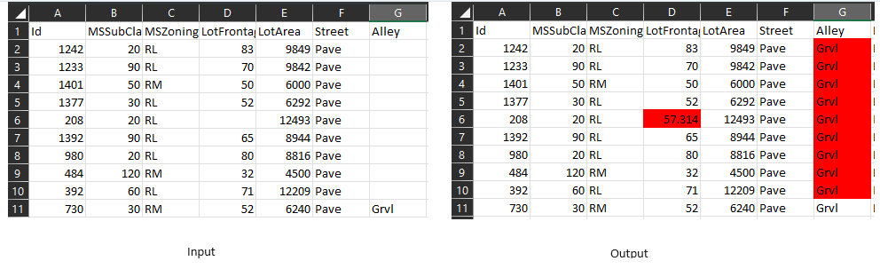

## **4.4 Deleting rows containing more than a particular number of missing values (Example: delete rows with the number of missing values is more than 50% of the number of attributes):**

Command line:

|  |
| --- |
| python function4.py house-prices.csv --threshold 0.1 --output_file 4.csv |

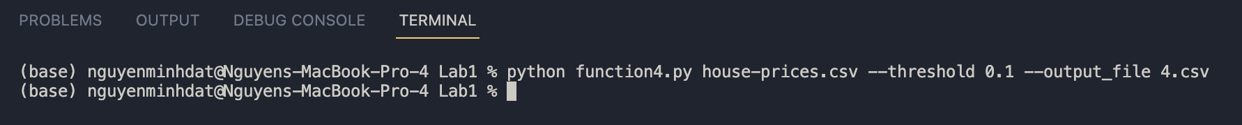

After selecting this function, you need to provide a threshold or default value which will be 10%. This means that rows with more than 10% missing data for attributes will be removed from the dataset. The result values will be exported to the file "4.csv".

With house-prices.csv data set and threshold = 10%:

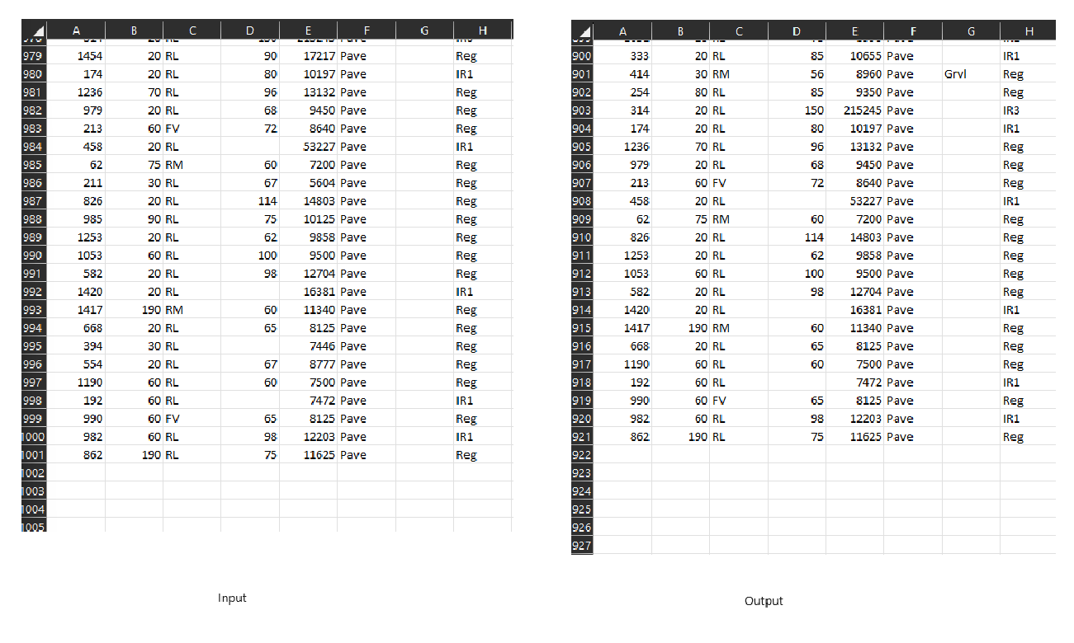

In this case, after processing, the output will have only 920 rows of data remaining, given that the dataset originally had 1000 rows, and the threshold was set at 10%.

## **4.5 Deleting columns containing more than a particular number of missing values (Example: delete columns with the number of missing values is more than 50% of the number of samples):**

Command line:

|  |
| --- |
| python function5.py house-prices.csv --threshold 0.1 --output_file 5.csv |

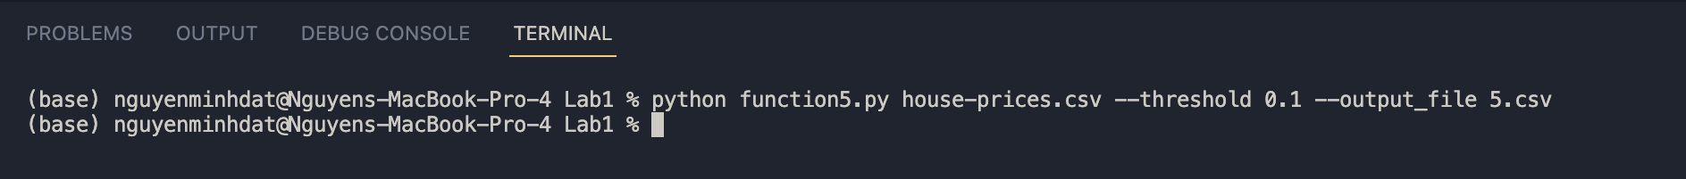

Similarly, in function 4, the processing is done column-wise. The result will be exported to a file "5.csv".

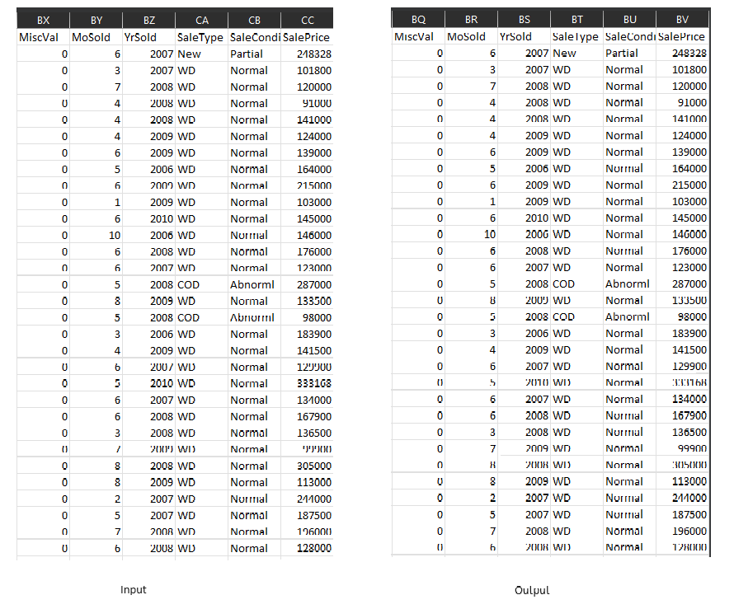

Our input data ends in the "sale price (CC)" column, and after processing, the data ends at the "sale price (BV)" column. It appears that some columns that didn't meet the standards have been removed.

## **4.6 Delete duplicate samples:**

Command line:

|  |
| --- |
| python function6.py house-prices.csv --output_file 6.csv |

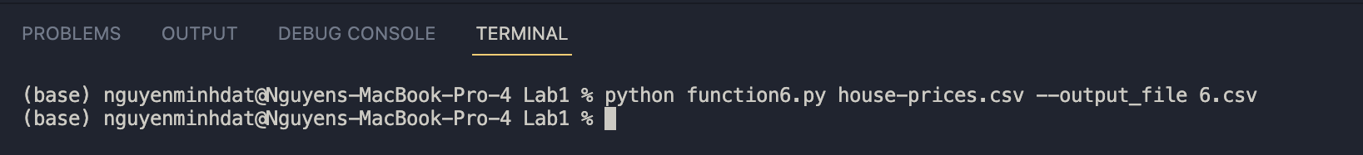

This function ensures that our dataset no longer contains duplicate data. The result will be exported to a file "6.csv".

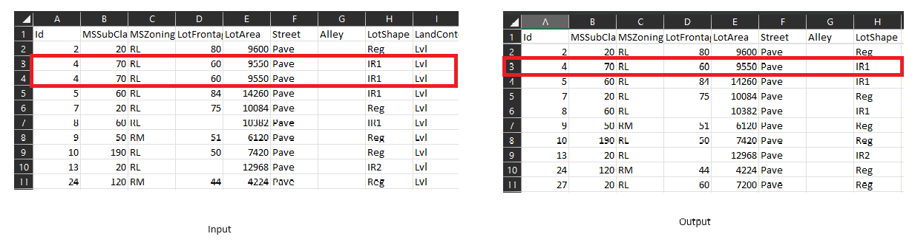

You've sorted the input file in ascending order based on the "ID" column (column A) for testing purposes. You've noticed that there are two rows with the same ID (ensured that these rows are identical in every column). Due to the large number of columns, it's not possible to scan all of them, so you've provided an example with 6 representative columns showing a case of duplicate data. After processing, the output file no longer contains duplicate entries.

## **4.7 Normalize a numeric attribute using min-max and Z-score methods:**

Command line:

|  |
| --- |
| python function7.py house-prices.csv --method min-max --output_file 7.csv |

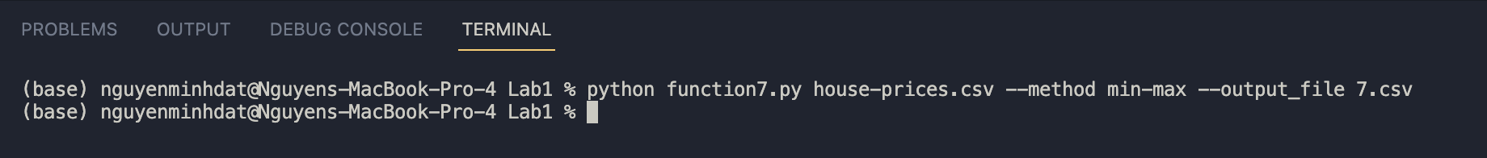

In this function, we will normalize the columns with numerical attributes using either the Min-Max scaling or Z-score normalization. The result will be exported to a file "7.csv"

Min-Max scaling is defined according to the formula:

***normalized_value = (value - min) / (max - min)***

where:

normalized_value: The value after normalization.

value: The current value under consideration.

min: The minimum value of the attribute being considered.

max: The maximum value of the attribute being considered.

The resulting normalized_values will be in the range [0, 1] and will represent the attribute values after normalization**.**

Z-Score is defined according to the formula:

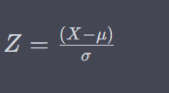

where:

Z : The Z-score of the data point.

X : The data point (the value of the attribute you want to normalize).

μ : The mean (average) of the data.

σ : The standard deviation of the data.

In the case of Z-score normalization, the resulting value (Z) indicates how far the original value is from the mean of the attribute, expressed in terms of standard deviations. A positive Z value indicates that the value is greater than the mean, and a negative Z value indicates that the value is smaller than the mean. The magnitude of the Z value indicates the distance from the mean in terms of standard deviations, with larger magnitudes indicating greater deviations from the mean. This normalization method centers the data around the mean and scales it based on standard deviations.

With house-prices.csv data set and normalize a numeric attribute using min-max, we have the results:

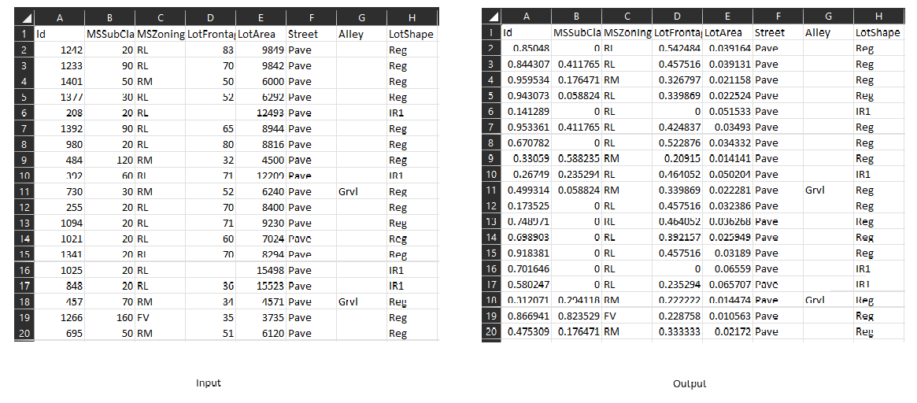

## **4.8 Performing addition, subtraction, multiplication, and division between two numerical attributes:**

Command line:

|  |
| --- |
| python function8.py house-prices.csv --col1 0 --col2 1 --operator + --output_file 8.csv |



In this function, we will select two columns with numerical attributes, and you can choose to perform addition, subtraction, multiplication, or division on these two columns to generate a new column. The result will be exported to a file "8.csv".

With house-prices.csv data set. We select the "ID" column (0) and the "MSSubClass" column (1) and perform addition to create a new column named "new_column" in the output file.

